**[](https://skill-lync.com/profiles/md-saquib-md-afzal-12hdy)**

**INTERNSHIP PROJECT REPORT**

(Under The Guidance Of [Junie Denny Solomon](https://www.linkedin.com/in/junie-denny-1b737120/) Mam)

Name: [Md Saquib Md Afzal](https://www.linkedin.com/in/mohammad-saquib9225574779/)

Name Of The Organization For Internship: Skill Lync

Project Title: [Responsive E-Commerce Website Attire Home](https://github.com/MDSAQUIBMDAFZAL/attire-home)

GitHub: <https://github.com/MDSAQUIBMDAFZAL>

LinkedIn: <https://www.linkedin.com/in/mohammad-saquib9225574779/>

**INTRODUCTION**

**Overview**

* [Attire Home](https://github.com/MDSAQUIBMDAFZAL/attire-home) Is A Responsive E-Commerce Website. The Technologies Used In This Project Are HTML, CSS, Vanilla JavaScript, And Bootstrap. There Are A Few Important Modules In The Project, Like The Home Page, Collection, Product Listing Page, Special Blog, About Us Page, Etc.
* For The Sign-In Button, We Are Using Models For Creating A New Account And Signing In To An Existing One. [Attire](https://github.com/MDSAQUIBMDAFZAL/attire-home) E-Commerce Is The Buying And Selling Of Men's And Women's Apparel Over An Electronic Network, Primarily The Internet. These Business Transactions Occur From Business To Consumer, And E-Commerce Shops Have Become Part Of Our Daily Lives.
* Technological Advancement Has Made It Possible For People To Sit In The Convenience Of Their Homes And Still Shop Online Without Going To A Physical Shop.
* So This Project Is Meant To Design An Ecommerce Online Shop So That People Will Be Able To Purchase Their Goods And Services Online. This Project Is Mainly Divided Into Two Main
* **Categories:**
* The Administrators And The Customers/Users. The Store Manager And The Staff Members Operate As Administrators.
* They Can Add, Edit, Update, Or Delete Products, Allowing Them To Change Product Names And Prices And Add Or Remove Products.
* The Customer Can Search For Products, Update The Cart, Remove Products From The Cart, And Check Out From The Shop. The Customer Is Also Able To Update His Information, Such As Names, Addresses, And Other Data.
* The User Is Only Able To Browse The Online Shop And Add A Product To The Cart. The User Is Limited To The Use Of The Shop.
* **Purpose**
* The Purpose of Apparel E-Commerce Websites Is to Sell Products to Users. This Website Is Carefully Optimized to Achieve a High Percentage of Purchases.
* To Achieve Success, E-Commerce Websites Integrate All the Latest Online Closing and Upselling Techniques Available, Which Have Been Proven to Increase the Chances That a Visitor Will Make a Purchase.
* Removing Friction During the Purchasing Process, Making the Checkout Smooth and Easy, Making the Website Fast and Attractive, Up-Selling Users on Related Products, Incentivizing Buyers, Reducing Cart Abandonment, Nurturing Past Buyers to Buy Again, Remarketing to Past Visitors Who Haven't Yet Purchased, Using the Proper Payment Options, And Having a Mobile-Ready Design Were All Critical Elements in Developing a Foot World E-Commerce Website.

**FLOW CHART**

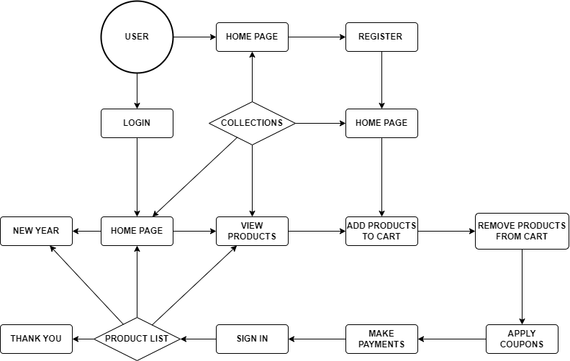

**MAIN FEATURES**

* **Admin**
* The Administrator Has All the Rights to Access the System. He Is the One Who Has All Rights to View the Member's and Product's Details and Modifies Those Details. He Can Add Various Products Based on The Category.
* Furthermore, He Can Also Set the Available Quantity of a Product and Its Reasonable Price. He Can Also Set Discounts for Various Occasions.
* Admins Can Also View the Details of a Member. The Admin Has the Power to Generate the Scratch Card So That Users Can Also Use the Recharge Card to Buy Various Products.
* **User**
* The User Can Log in To the System Using His Specific Email and Password. The User Can View the Products and Order Them According to Their Own Needs.
* He Can View His Profile and Update His Details. He Can Update His Personal Information by Logging into The System.
* Users Can Easily Find Various Products by Using the Search Option and Updating Their Details. He Can Update His Personal Information by Logging into The System.
* Users Can Easily Find Various Products by Using the Search Option.
* **Country Selection**
* When The User Clicks on The Country, It Allows Them to Select from Various Countries, And the Contact Number and Flag Change Accordingly.
* **Importing Products From A Database**
* When The User Clicks the Shop Now or View More Button, They Are Taken to The All-Products Page, Where the Information for Various Products Is Loaded from A Database Via a Bogus Server.
* This Feature Was Implemented Using AJAX Calls and JavaScript. The Product Information on The Server Was Stored in JSON Format.
* **Cart Page Implementations**
* Users Can Add Multiple Products to The Cart by Hovering Over the Mouse in The Latest Section of The Homepage, Where Different Products Are Displayed.
* The Cart on The Top Navigation Bar Increments as The User Adds Products, And Upon Clicking on It, It Takes Them to The Cart Page.
* Here Users Can Choose Their Preferred Size for Various Products and Change the Quantity of Their Order as Needed. Users Can Also Permanently Remove Products from Their Carts by Clicking the Remove Button or Adding a Specific Product to Their Wish List by Clicking the Add to Wish List Button.
* When Satisfied, The User Can Click on the “Proceed to Checkout” Button to Go to The Checkout Page.
* **Checkout Page Implementations**
* When Users Arrive at The Checkout Page, They Must Go Through Three Steps Before Placing Their Order.
* First, They Need to Sign in Successfully; Second, They Will Have to Enter Their Address and Contact Information; And Finally, They Will Have to Choose a Mode of Payment. After That, The User Can Click the Place Order Button to Successfully Place the Order, And the Thank-You Page Will Appear.
* If Users Want to Go Back to Any Stage, They Need to Click on The Change Button to Make Any Changes.
* **Profile Creation and Updating**
* Users Can Access the My-Profile Page by Clicking the Profile Link in The Top Navigation Bar.
* Here, The User Is Shown Their Information Like Name, Gender, Email, Location, Etc., Among Others.
* The User Can Edit These Details by Clicking on The Edit Button, Which Takes Them To the Edit Profile Page.
* Here, Users Can Change the Entire Information or Edit Previously Saved Information and Click on The Save Details Button to Save The Details. After Doing So, The User Is Returned to The My Profile Page, Where the Updated Information Is Displayed.
* **HARDWARE AND SOFTWARE REQUIREMENTS**
* **Hardware Required**
* Processor : Pentium IV or Higher Processor
* RAM : 2 GB Or Above
* Hard Disk : 50 GB Or Above
* Input Devices : Keyboard, Mouse
* Output Devices : Monitor
* **Software Required**
* Operating System : Linux, Ubuntu, Mac, Windows XP, 7, 8, 8.1, 10, And Above
* Frontend : HTML, CSS, Bootstrap, JavaScript, AJAX, JSON
* Tools : VS Code, Live Server, Browser

**HTML**

* Every Webpage You Look at Is Written in A Language Called HTML. You Can Think of HTML As the Skeleton That Gives Every Webpage Structure.
* HTML Is Used to Add Paragraphs, Headings, Images, And Links to A Webpage. In The Editor to The Right, There's A Tab Called Test.Html.
* This Is the File We’ll Type Our HTML Into. Like Any Language, It Has Its Special Syntax.
* A Browser's Job Is to Transform the Code in Test.Html into A Recognizably Structured Webpage.
* It Knows How to Lay Out the Page by Following the HTML Syntax.

**CSS**

* Cascading Style Sheets (CSS) Is A Style Sheet Language Used for Describing the Presentation of a Document Written in A Markup Language Such as HTML Or XML (Including XML Dialects Such As SVG, Math, Or XHTML).
* CSS Is a Cornerstone Technology of The World Wide Web, Alongside HTML And JavaScript. CSS Is Designed to Enable the Separation of Content and Presentation, Including Layout, Colors, And Fonts.
* This Separation Can Improve Content Accessibility, Provide More Flexibility and Control in The Specification of Presentation Characteristics, and Enable Multiple Web Pages to Share Formatting by Specifying the Relevant CSS In a Separate.
* CSS File, Which Reduces Complexity and Repetition in The Structural Content, And Enables The.
* CSS File to Be Cached to Improve the Page Load Speed Between the Pages That Share the File and Its Formatting.
* Separation Of Formatting and Content Also Makes It Feasible to Present the Same Markup Page in Different Styles for Different Rendering Methods, Such as On-Screen, In Print, By Voice (Via A Speech-Based Browser or Screen Reader), And on Braille-Based Tactile Devices.
* CSS Also Has Rules for Alternate Formatting If the Content Is Accessed on A Mobile Device.
* The Name “Cascading” Comes from The Specified Priority Scheme to Determine Which Style Rule Applies If More Than One Rule Matches a Particular Element. This Cascading Priority Scheme Is Predictable.

**JavaScript**

* JavaScript, Often Abbreviated As JS, Is A Programming Language That Is One of The Core Technologies of The World Wide Web, Alongside HTML And CSS.
* As Of 2022, 98% Of Websites Use JavaScript on The Client Side for Webpage Behavior, Typically Incorporating Third-Party Libraries. All Major Web Browsers Have a Dedicated JavaScript Engine to Execute the Code on Users' Devices.
* JavaScript Is a High-Level, Often Just-In-Time Compiled Language That Conforms to The ECMAScript Standard. It Has Dynamic Typing, Prototype-Based Object Orientation, And First-Class Functions.
* It Is a Multi-Paradigm, Supporting Event-Driven, Functional, And Imperative Programming Styles. Furthermore, It Has Application Programming Interfaces (Apes) For Working with Text, Dates, Regular Expressions, Standard Data Structures, And the Document Object Model (DOM).
* The ECMAScript Standard Does Not Include Any Input/Output (I/O) Facilities, Such as Networking, Storage, Or Graphics Facilities.
* In Practice, The Web Browser or Other Runtime System Provides JavaScript Apes For I/O. JavaScript Engines Were Originally Used Only in Web Browsers, But They Are Now Core Components of Some Servers and A Variety of Applications. The Most Popular Runtime System for This Usage Is Node.js.
* Although Java and JavaScript Are Similar in Name, Syntax, And Respective Standard Libraries, The Two Languages Are Distinct and Differ Greatly in Design.
* **Coding Best Practices Used**
* DRY Stands For Do Not Repeat Yourself.
* Write Clean, Readable, And Organized Code
* Write Comments Describing Functions And Code Blocks
* Reuse Code As Much As Possible.

[**HOME PAGE**](https://github.com/MDSAQUIBMDAFZAL/attire-home)

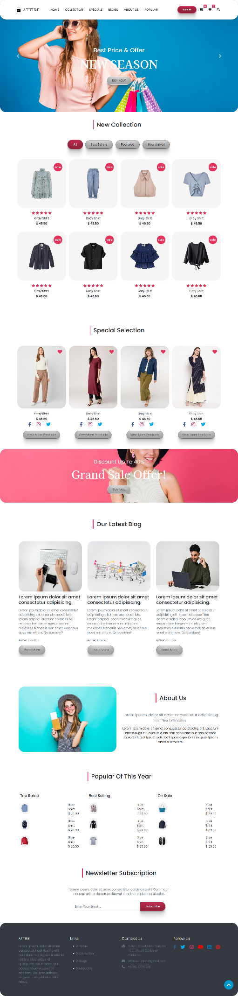



[**NEW COLLECTION SECTION**](https://github.com/MDSAQUIBMDAFZAL/attire-home)

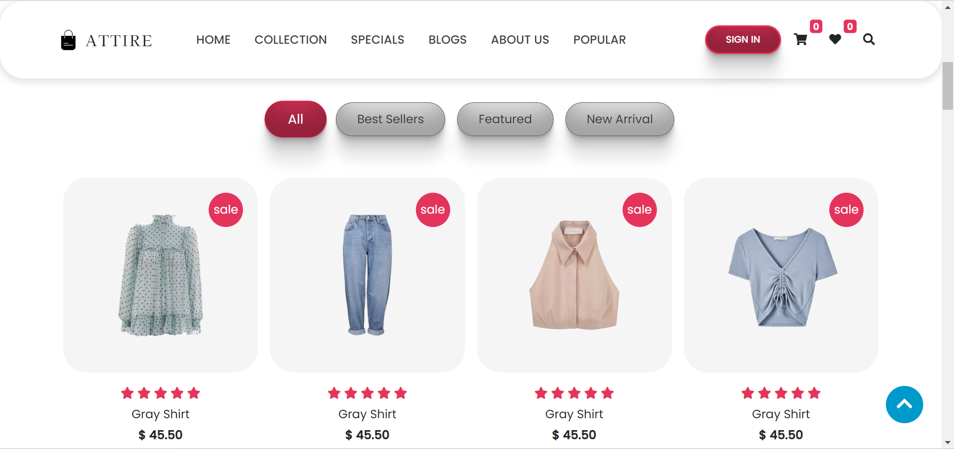

[**SPECIAL SECTION**](https://github.com/MDSAQUIBMDAFZAL/attire-home)

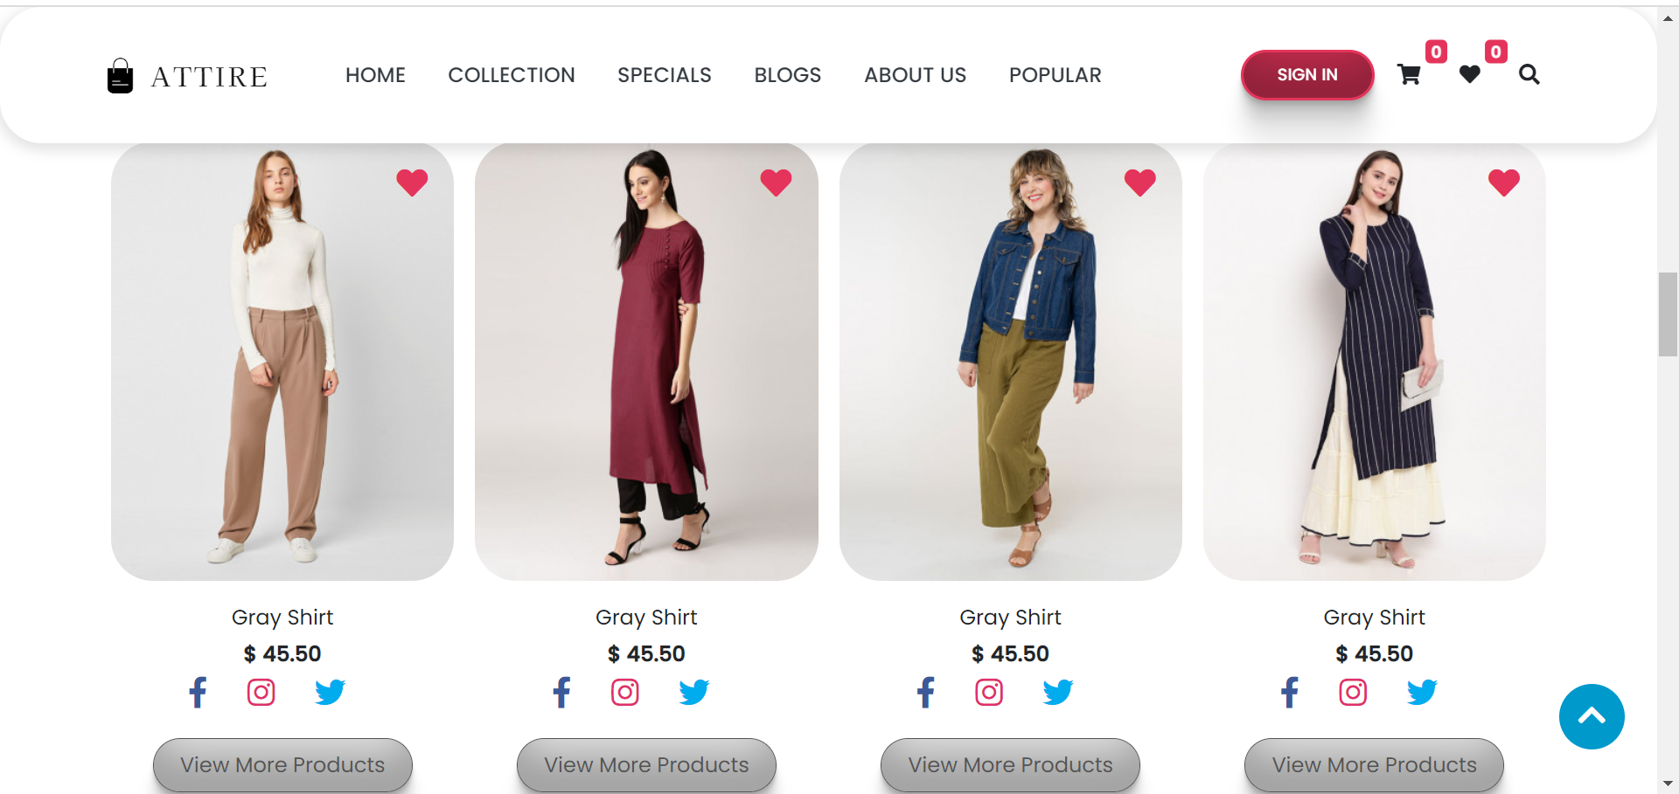

[**BLOGS SECTION**](https://github.com/MDSAQUIBMDAFZAL/attire-home)



[**ABOUT US SECTION**](https://github.com/MDSAQUIBMDAFZAL/attire-home)

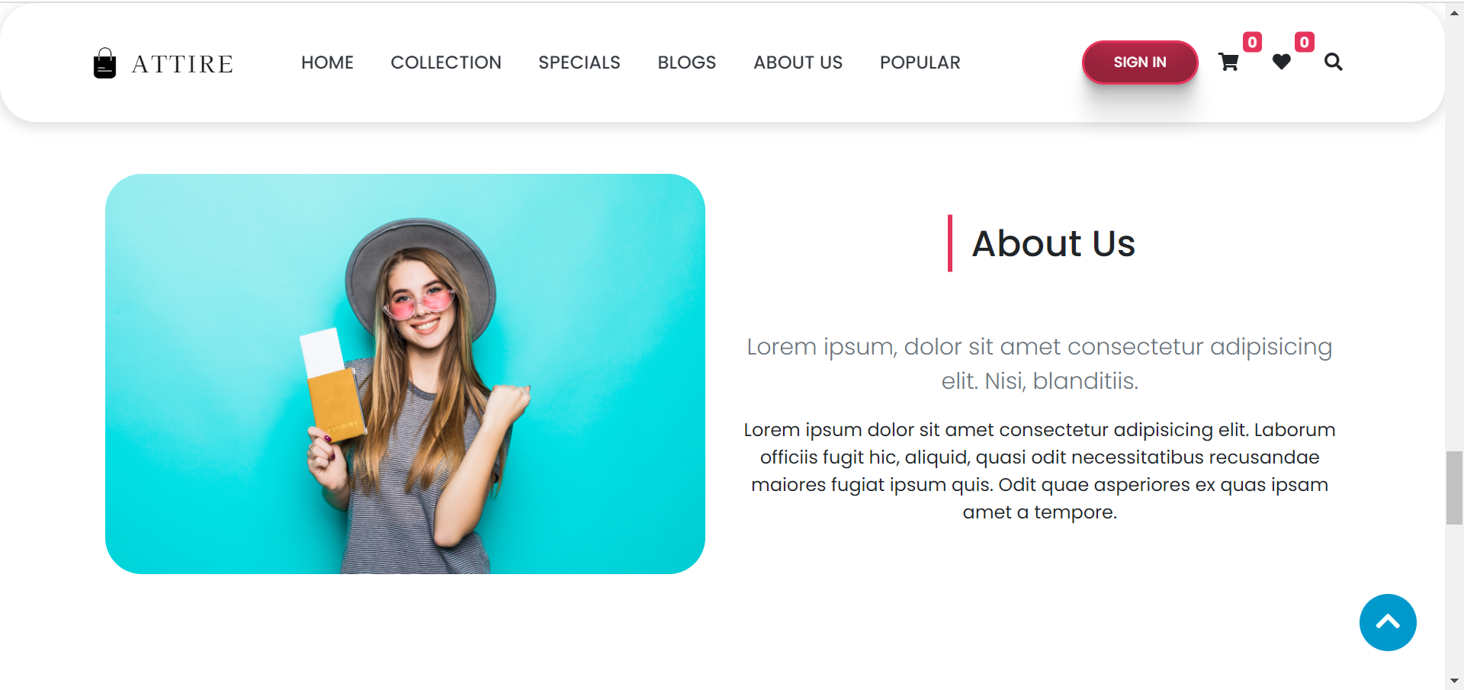

[**POPULAR SECTION**](https://github.com/MDSAQUIBMDAFZAL/attire-home)

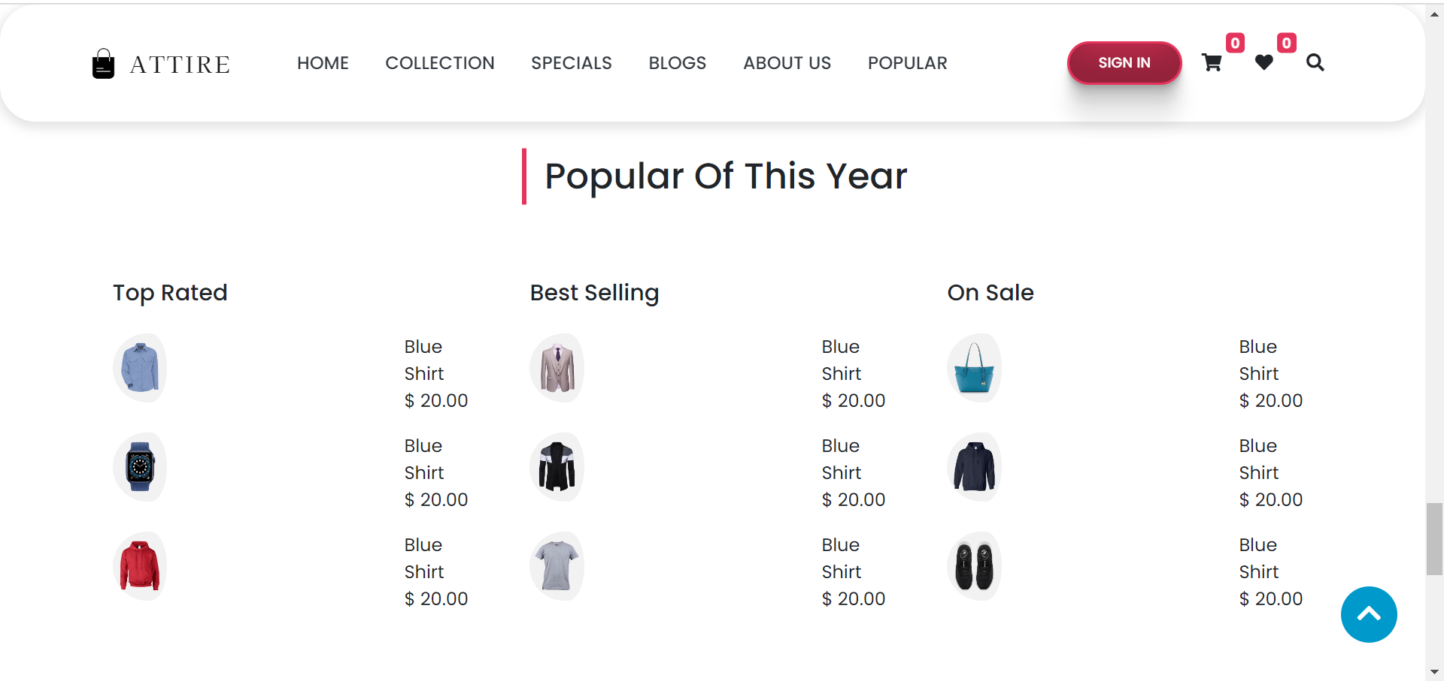

[**SIGN IN PAGE**](https://github.com/MDSAQUIBMDAFZAL/attire-home)

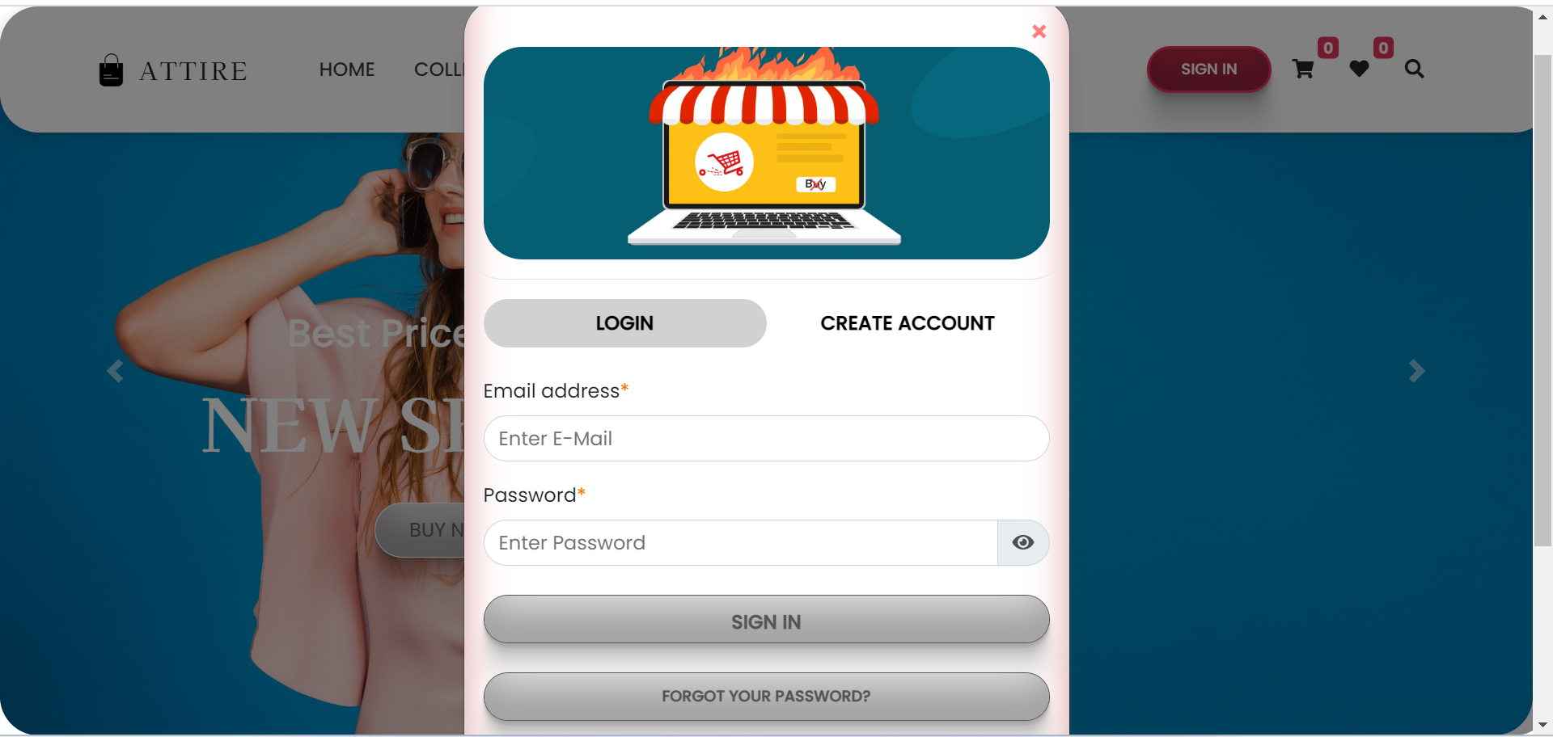

[**PRODUCT LIST PAGE**](https://github.com/MDSAQUIBMDAFZAL/attire-home)

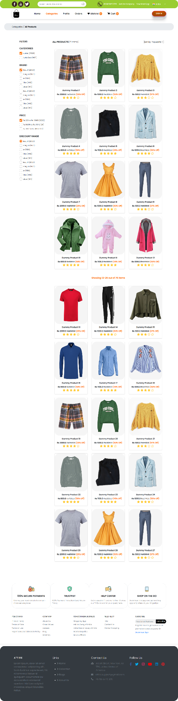

[**PRODUCT LIST FOOTER**](https://github.com/MDSAQUIBMDAFZAL/attire-home)

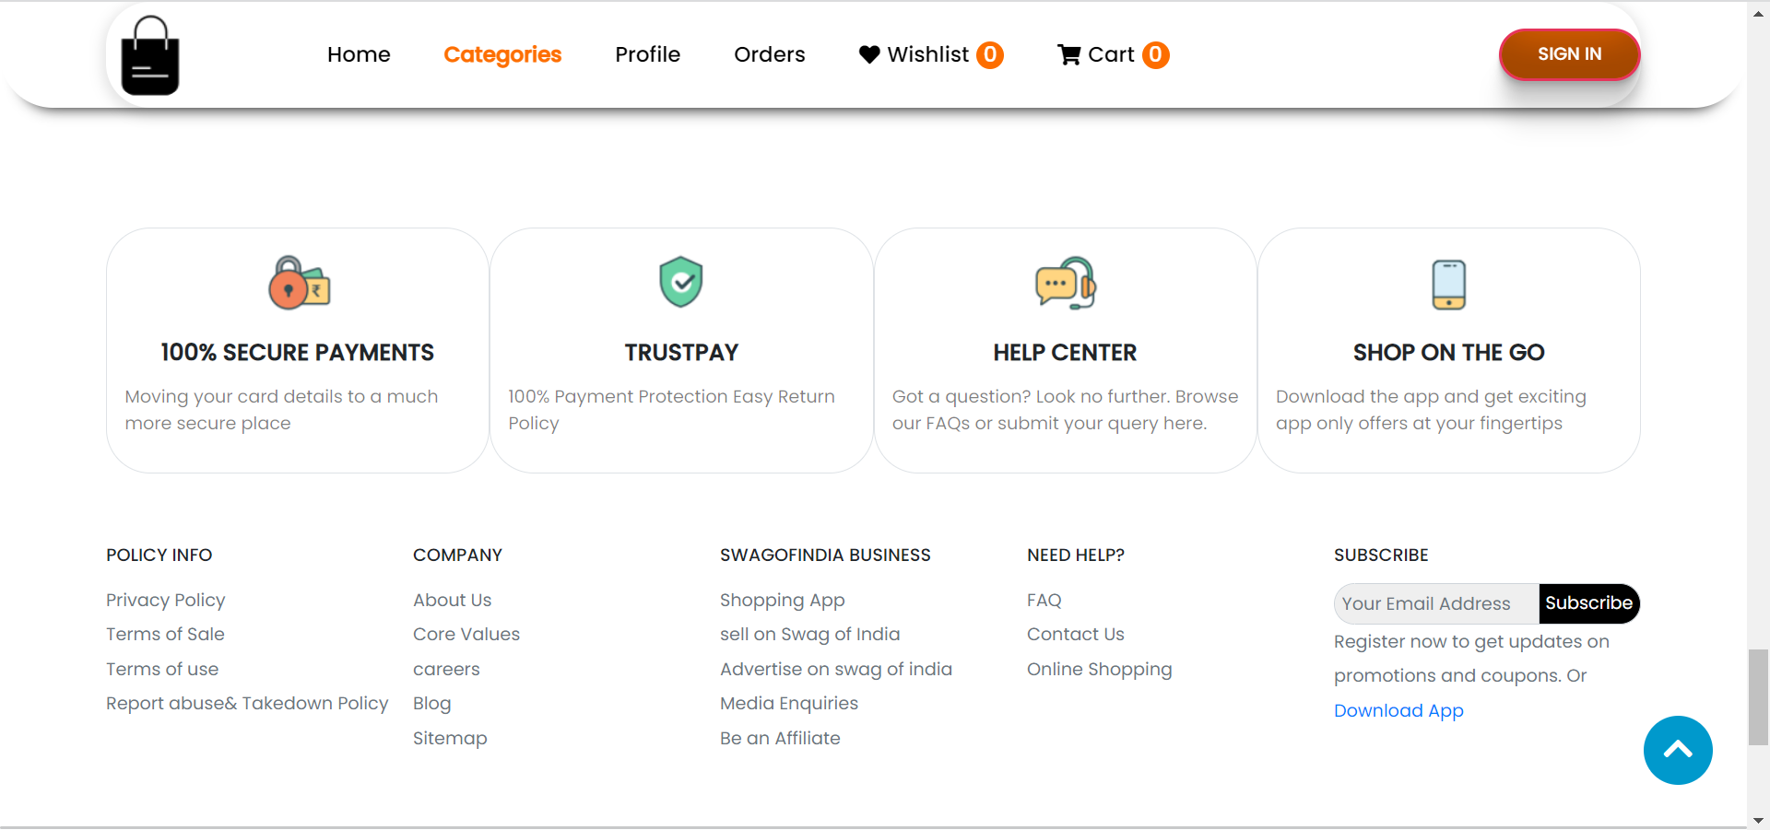

[**CART PAGE**](https://github.com/MDSAQUIBMDAFZAL/attire-home)

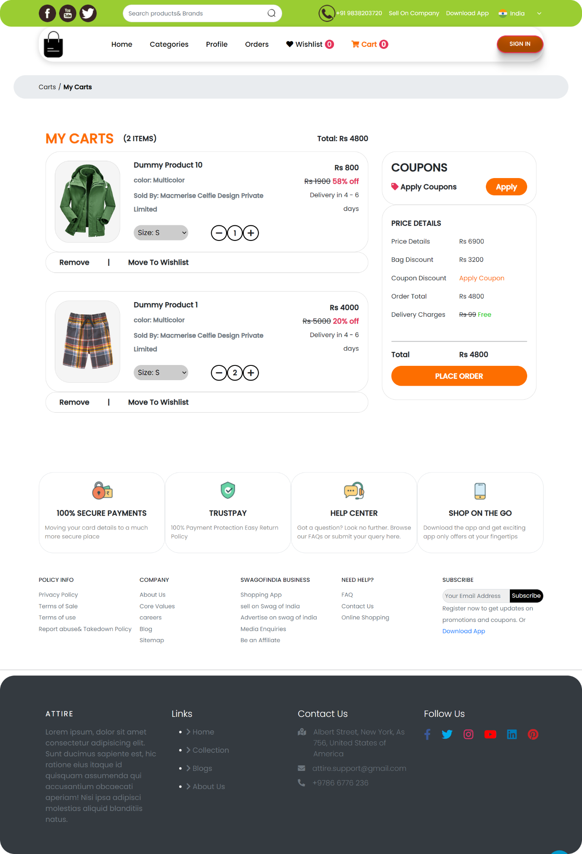

[**PRODUCT VIEW AND COMMENTS**](https://github.com/MDSAQUIBMDAFZAL/attire-home)

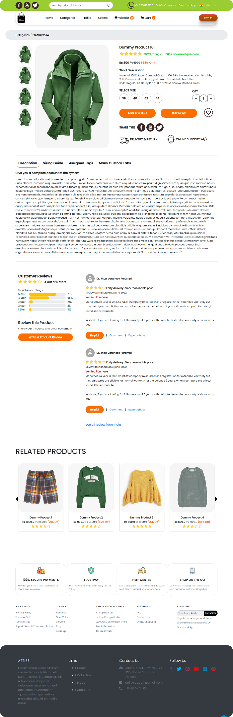

[**CHECKOUT PAGE**](https://github.com/MDSAQUIBMDAFZAL/attire-home)

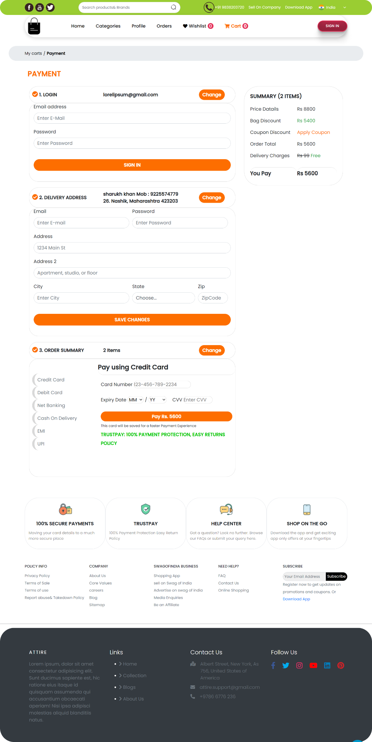

[**NEW YEAR PAGE**](https://github.com/MDSAQUIBMDAFZAL/attire-home)



[**THANK YOU PAGE**](https://github.com/MDSAQUIBMDAFZAL/attire-home)



* **Future work**
* Password Hide/Show Function
* Using Buttons Instead of Hovering Icons for Cart, Wish List, And Product View on Phones and Tablets
* Connecting Facebook, Twitter, And Gmail APIs for Login
* Creating A Backend and Database, As Well As Connecting It To The Front End, To Create a Full-Fledged E-Commerce Website
* It should be included as a payment gateway.
* Can be incorporated into the inventory management system.
* Can be added to multiple branches
* can be added multilingually to this site.
* And many features can be added to this project to make it more robust.
* **Conclusion**

This Project Is Only a Humble Venture to Satisfy a Shop’s Needs. Several User-Friendly Codes Have Also Been Adopted. This Package Will Prove to Be Powerful in Satisfying All the Requirements of The Organization. Software Planning Aims to Provide a Framework That Allows Managers to Make Reasonable Estimates in A Limited Time Frame.

The Beginning of The Software Project Should Be Updated Regularly as The Project Progresses. This Website Provides a Computerized Version of The Shop Manipulation System, Which Will Benefit the Users as Well As The Visitors to The Shop. It Makes the Entire Process Available Online, Where Users Can Access It.

Search For and Buy Various Products. It Also Has a Login Option for Regular Users. The System Through Which Users Can Log in And Check the Status of Ordered Items as Well as Make Requests or Give Some Suggestions Includes the Ability for Administrators to Log in And Add Various Settings. Item, Review Users' Activities, Give an Occasional Discount, And Also Add Info About Different Events for The Customer.

**\*\*\***